Use Case Diagram
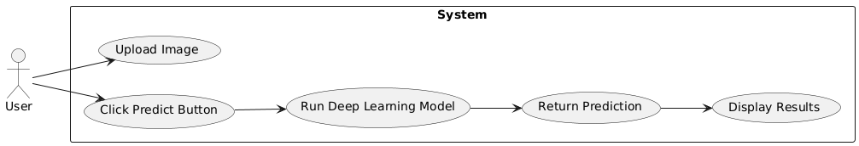

Class Diagram
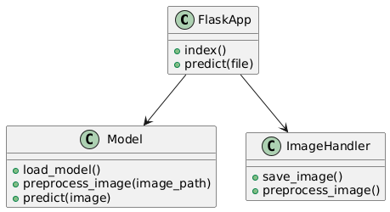
Activity Diagram
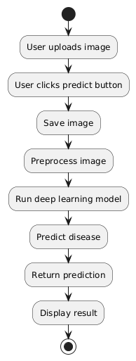
Sequence Diagram
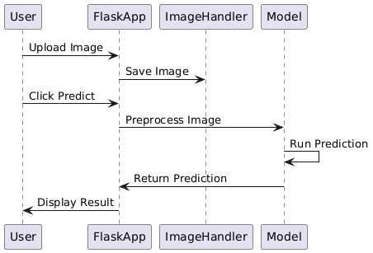
Collaboration Diagram
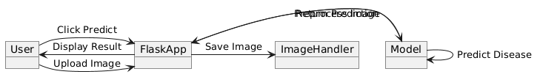
Component Diagram
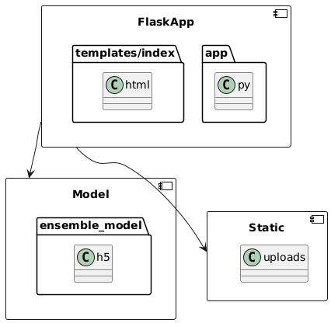
Deployment Diagram
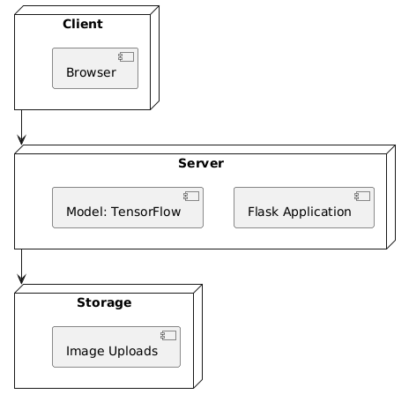
Data Flow Diagram Level 0 (DFD-0)
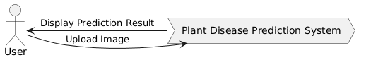
Data Flow Diagram Level 1 (DFD-1)
